16SW180
 |  | Department of Software Engineering
 | Mehran University of Engineering and Technology, Jamshoro
 | Course: SWE324 - Data Warehousing and Data Mining
Instructor | Rabeea Jaffari | Practical/Lab No. | 10
Date | 2nd Aug 2018 | CLOs | CLO-4: P3 & P4
Signature |  | Assessment Score | 1 Marks

Topic | Data mining technique: association rule analysis
Objectives | - | To learn Data mining using Microsoft Azure Machine Learning
 |  | Studio.
 | - | To perform association rule analysis using Apriori algorithm in
 |  | Microsoft Azure ML Studio.

Lab Discussion: Theoretical concepts and Procedural steps

Class Task:
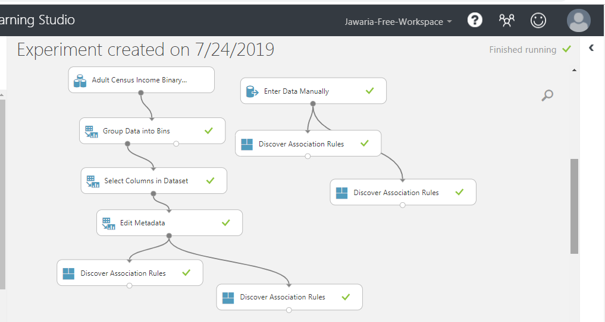
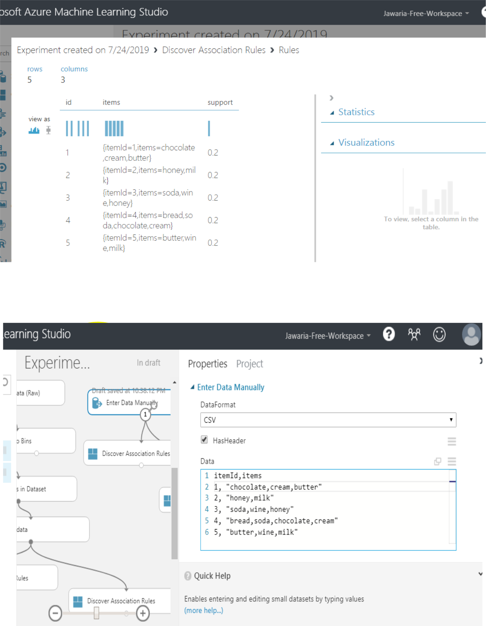

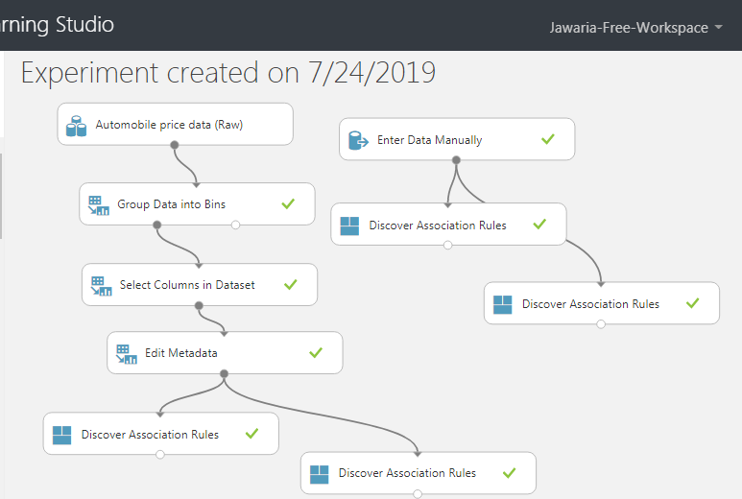
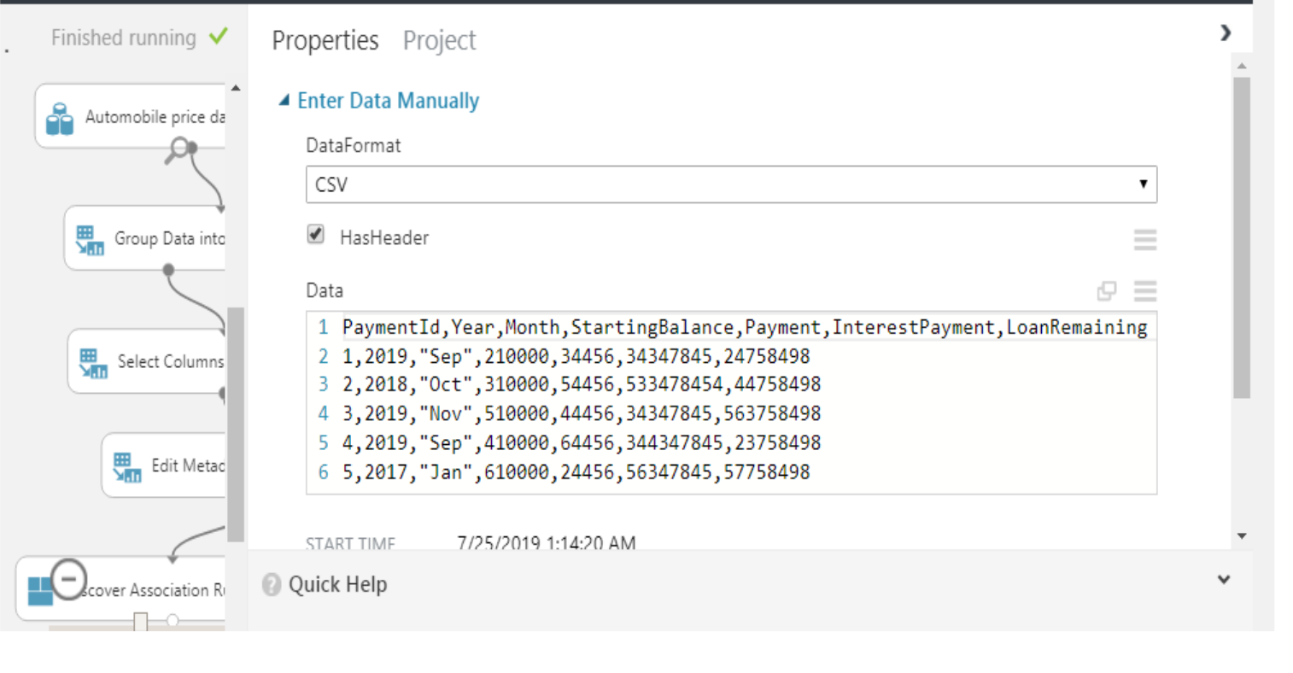
Take any dataset in CSV format and derive association rules and frequent item sets from it using any one of the approaches described a

